EVZ Foundation Award for Jewish-Muslim Solidarity
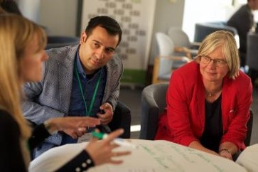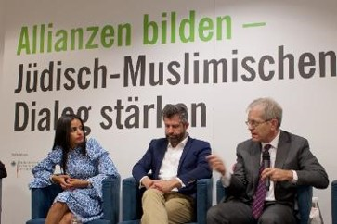
EVZ Foundation and Kreuzberg Initiative against Antisemitism want to award inspiring individuals, initiatives, projects, or organizations from the grassroots level, which take actions of one of the following natures:
- Jews and Muslims come together for tackling or resolving an issue affecting both communities;
- A Muslim or Jewish community/ individual/ organization supports the enhancement of the conditions of the other minority;
- Jews and Muslims find means to go further in understanding each other than a dialogue meeting (e.g., music, art, literature, community work, youth project, etc.)
The Award, an unconditional donation of € 5.000, will be awarded to one actor from Germany and one from the US at a ceremony in November 2019.
If you think you know any organization or individual that takes actions within the scope of the Award and complies with the criteria mentioned in the Call for Application, please fill out the attached form to back any initiative or propose your own initiative as a candidate. Please send us the completed Application Form until July 14, 2019, to award@kiga-berlin.org.
Call for Application
Application Form
-

